**Change Active Hours in Windows 10**

1. Type “settings” into the Windows search bar. Hit the enter key:

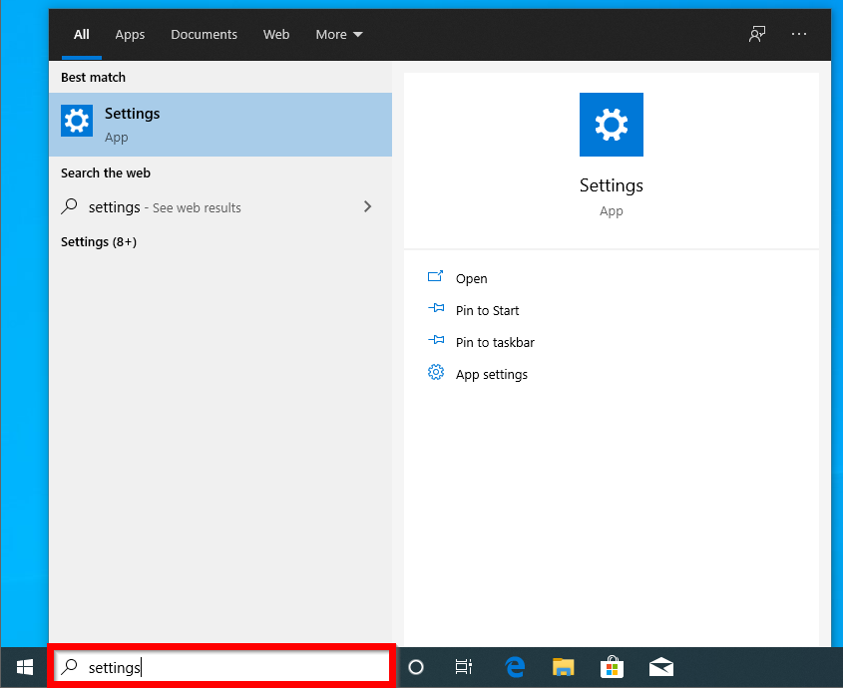

1. In the new window titled “Windows Settings”, click **Update & Security:**

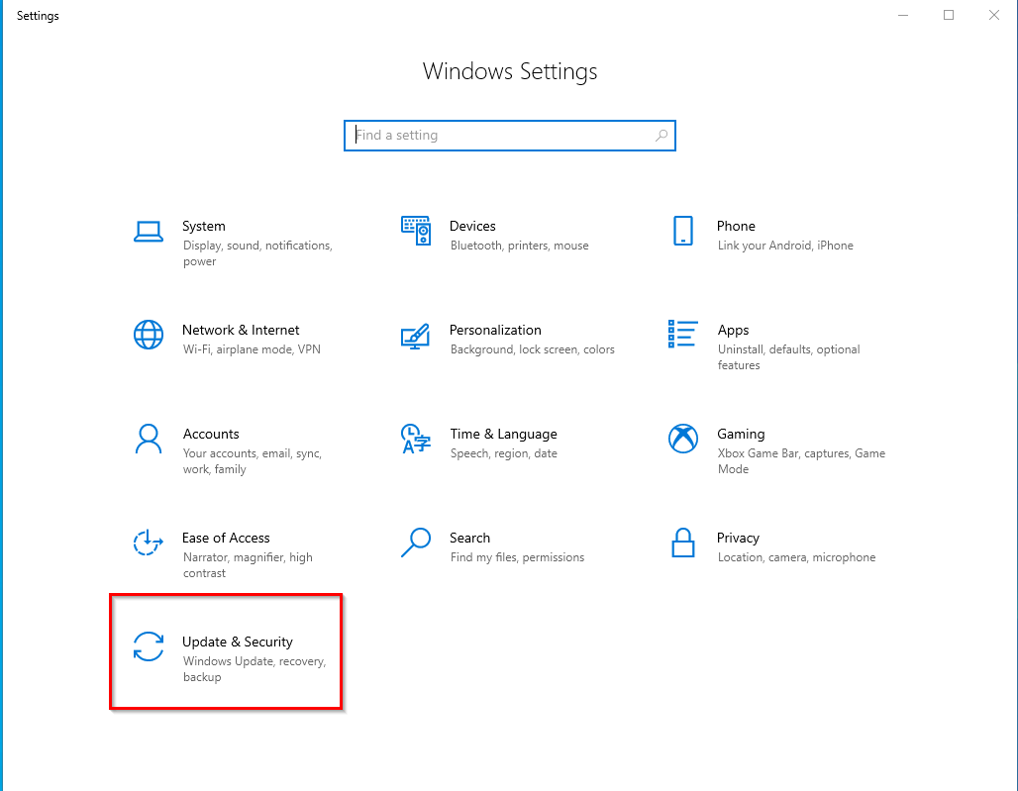

1. In the new window titled “Windows Update”, scroll down until you see **Change active hours** and click on it:

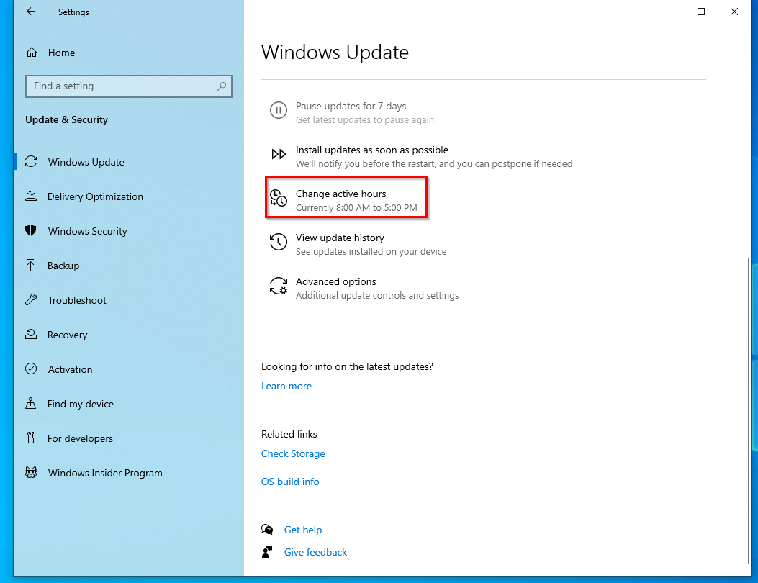

1. Click **Change:**

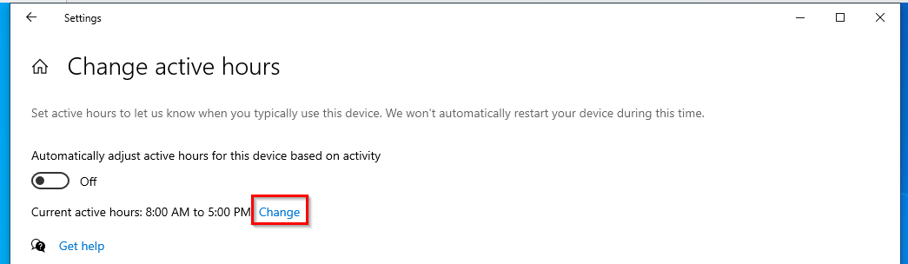

1. Below “End time”, click on the left-most (hours) box to change the end time of the device:

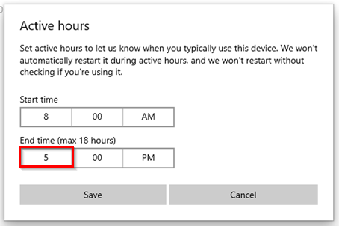

1. In the box that pops up, click on **4** to change the end time from 5:00PM to 4:00PM. Click the check mark:

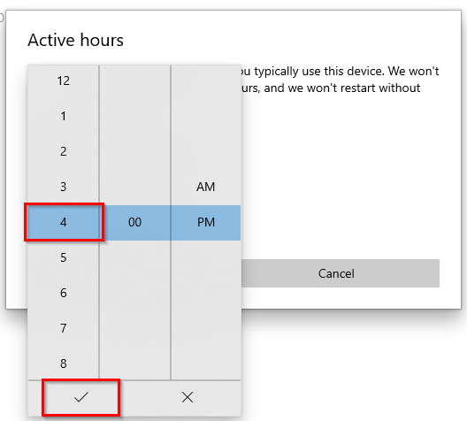

1. Click **Save** to save the changes:

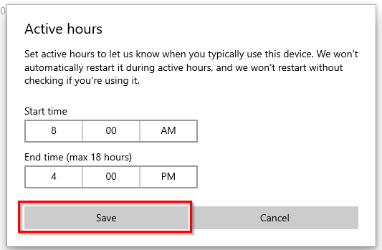

1. On device “Stuff02”, repeat **steps 1-4**.
2. This time, click on the left-most box below “Start time” to change the start time of active hours from 8:00AM to 9:00AM. Click the check mark:

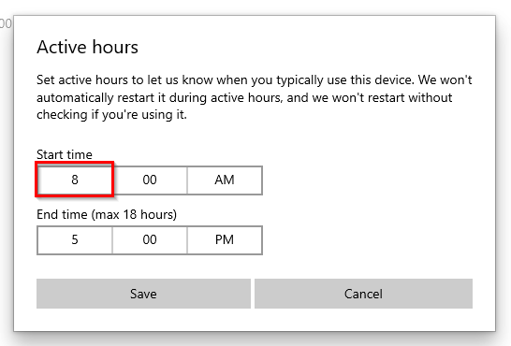

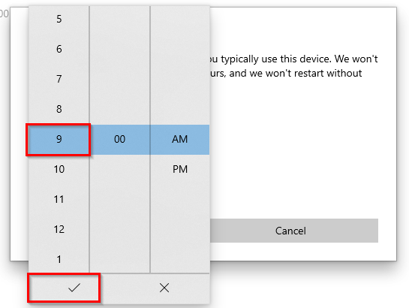

1. Click **Save** to save the changes:

